**MongoDb Task Day-2**

**Design database for Zen class programme**

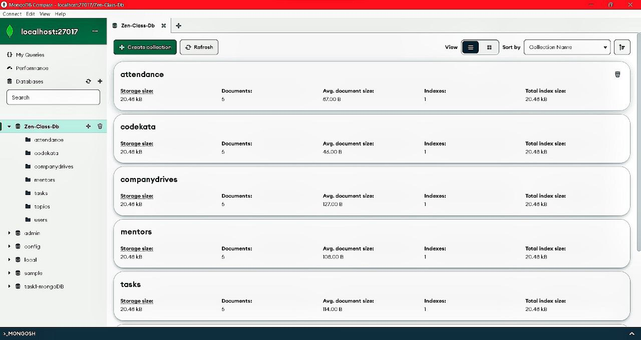

**Queries**

1. Find all the topics and tasks which are thought in the month of October

Answer :

db.topics.aggregate([

{

$lookup: {

from: "tasks",

localField: "taskid",

foreignField: "taskid",

as: "details"

}

},

{

$match: {

$and: [

{ topic_date: { $gte: new Date("2020-10-01"), $lte: new Date("2020-10-31") } },

{

$or: [

{ "details.due_date": { $gte: new Date("2020-10-01"), $lte: new Date("2020-10-31") } },

{ "details.due_date": { $exists: false } }

]

}

]

}

},

{

$project: {

_id: 0,

topic_date: 1,

topic: 1,

task: "$details.task"

}

}

])

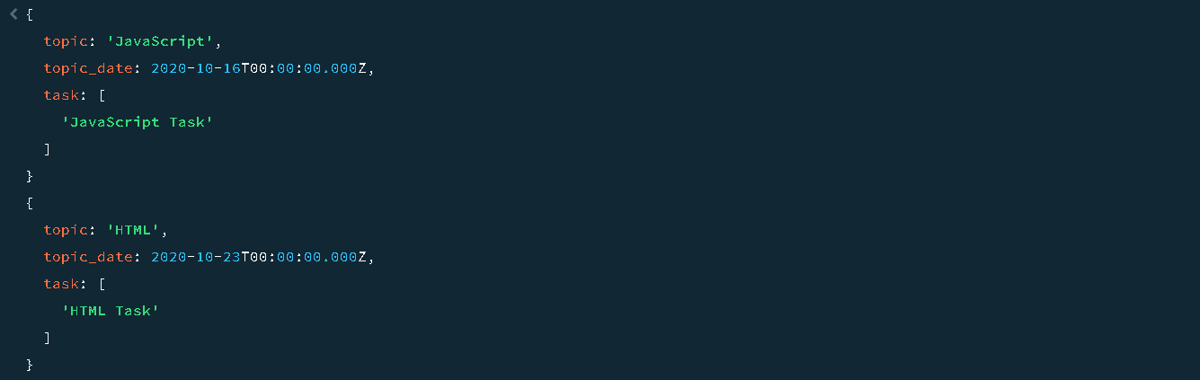

1. Find all the company drives which appeared between 15 oct-2020 and 31-oct-2020

Answer :

db.companydrives.find({$and:[{drive_date:{$gte:new Date("2020-10-15")}},

{drive_date:{$lte:new Date("2020-10-31")}}]},

{_id:0,drive_id:1,company:1,drive_date:1}).toArray()

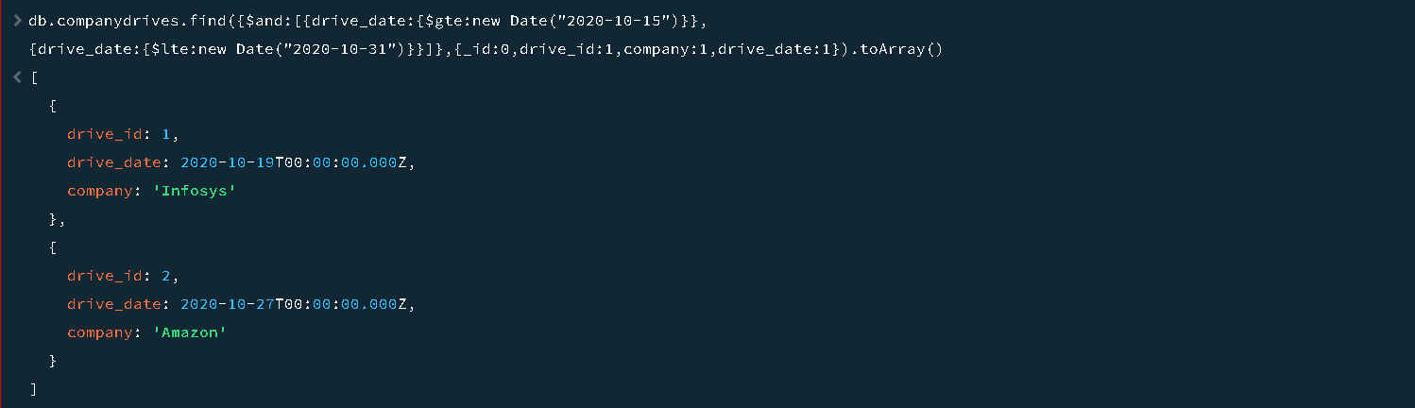

1. Find all the company drives and students who are appeared for the placement.

Answer :

db.companydrives.find({},{_id:0}).toArray()

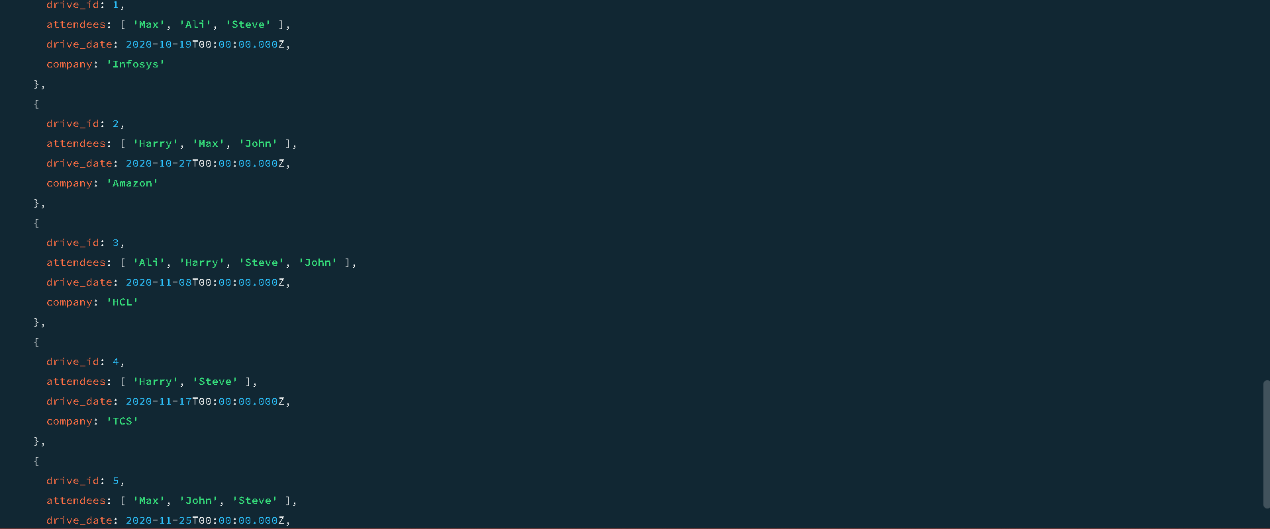

1. Find the number of problems solved by the user in codekata

Answer :

db.codekata.find({},{_id:0}).toArray()

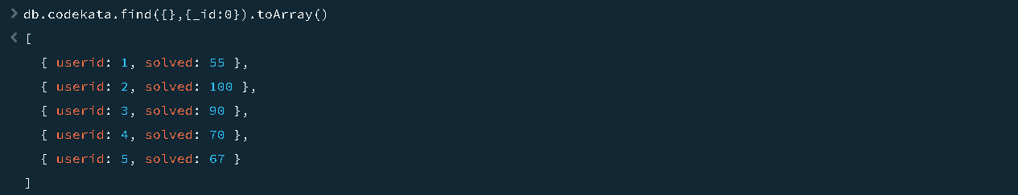

1. Find all the mentors with who has the mentee's count more than 15

Answer :

db.mentors.find({mentee_count:{$gt:15}},{_id:0}).toArray()

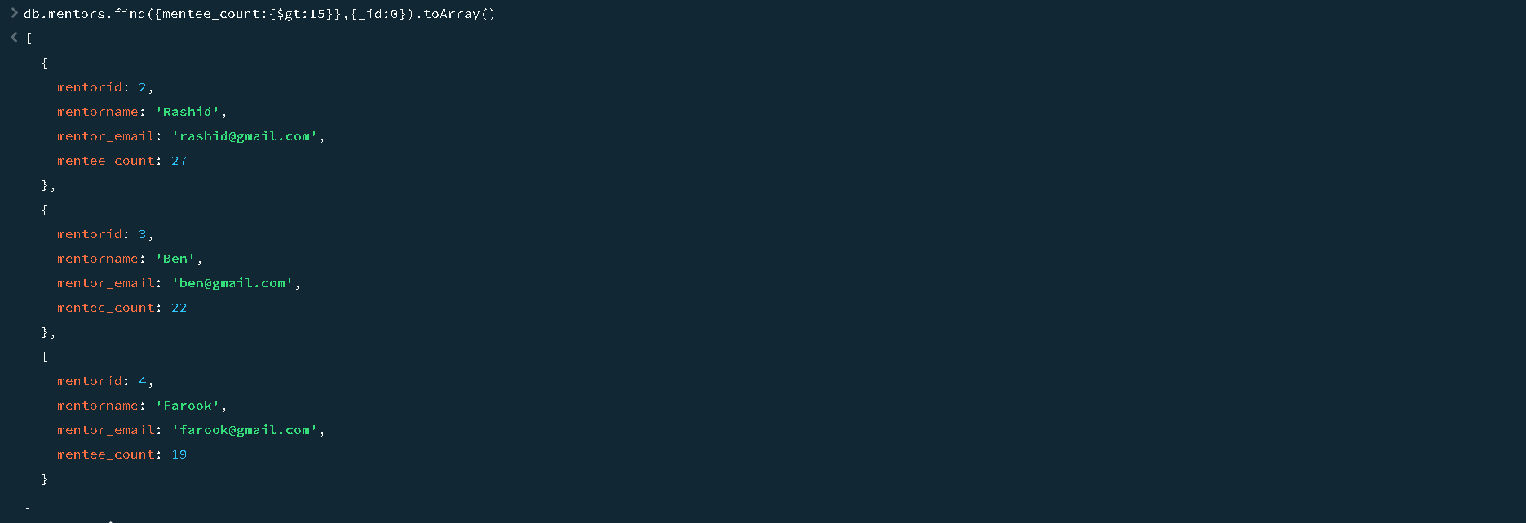

1. Find the number of users who are absent and task is not submitted  between 15 oct-2020 and 31-oct-2020

Answer :

db.users.countDocuments({

$and: [

{

absence: true,

},

{

task_pending: true,

},

{

date: {

$gte: new Date("2020-10-15"),

$lte: new Date("2020-10-31"),

},

},

],

})

